**MAJOR PROJECT**

**ON**

**IOT HOME BASED AUTOMATION**

**USING RASPBERRY PI**

**A close up of a logo

Description generated with high confidence**

**ABSTRACT:**

Internet of things is a technology of the future that has already started to touch our homes. Here we propose an IOT based home automation system using raspberry pi that automates home appliances and allows user to control them easily through internet from anywhere over the world. Our proposed system consists of a microcontroller based circuit that has lights and fan connected to it along with LCD display and Wifi connector interfaced with raspberry pi. Our system interacts with out online IOT system that IOT Gecko free web interface for controlling our home appliances with ease. After linking with IOT Gecko, the user is allowed to send load switching commands over IOT to our circuit. The circuit receives the commands over IOT by connecting to internet using wifi connector and then the raspberry processor processes these commands. After this the processor now processes these instructions to get user commands. It then displays these on an LCD display. Also it operates the loads (lights and fan) for switch them on/off according to desired user commands. Thus we automate home appliances over internet using raspberry pi.

**KEYWORDS:**

Home automation, Internet of things, Raspberry Pi, Sensors

# **i.INTRODUCTION:**

The Internet of Things (IoT) is the network of physical objects or "things" embedded with electronics, software, sensors, and network connectivity, which enables these objects to collect and exchange data . In home automation smart devices and sensors that sense and

the physical experience and convert into stream of information data. The major element of home automation based on IoT is sensor network and raspberry pi. Sensor networks are used for sensing and monitoring while raspberry pi collect the data monitor the data and depends on collected mange the device like fan, light, door motion

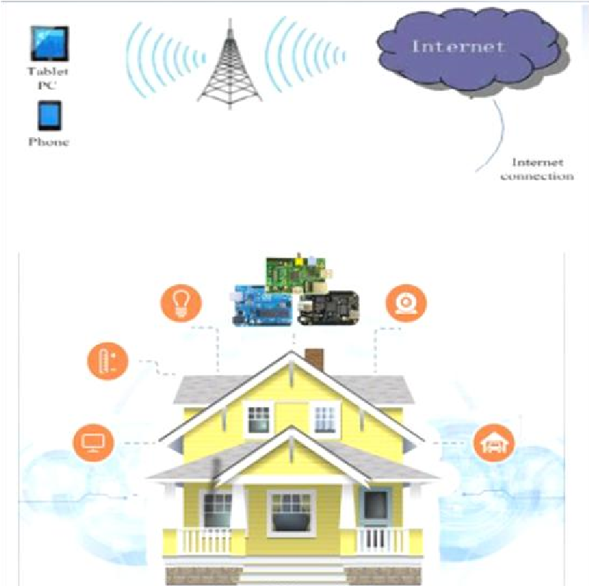

# **ii. HISTORY OF HOME AUTOMATION :**

Concepts for home automation were around for decades before becoming reality and featured in the writing of the 19th century.

The Electronic Computing Home Operator (ECHO) was highlight in the April 1968 edition of Popular Mechanics and had been expanded from a set of spare electronics. The ECHO never went commercial and a number of large companies played with the idea of computerizing the home, however it was the birth of the modern era of home automation technology.

The X10 standard was designed to allow transmitters and receivers to work over existing electrical wiring systems by broadcasting messages such as "turn off" and "turn on" via radio frequency.

X10 has a number of disadvantages

* Issues in wiring and interference
* At time of transmission command may lost

Fig. 1. Complete home automation using Raspberry pi

Thus, home automation can be defined as a mechanism removing as much human interaction as technically possible and desirable in various domestic processes and replacing them with programmed electronic systems. Ultimately it is a system that aims to heighten quality of life with the automation of household activity that may be controlled over the Internet or telephone.

and opening-closing of curtains. Suppose the ambient light is less that I am going to feel darkness then according to ambient light its automatically open the curtains.

* The run mode:
  + The central processing unit (CPU) and all functionality of the ARM11 core are available and powered up.
* The standby mode :
  + The main core clocks are shut down (the parts of the CPU that process instructions are no longer running) although the power circuits on the core are still active. In this mode, known as ‘‘Wait for Interrupt’’ (WFI) mode, the core can be quickly woken up by a process generating a special call to the CPU called an interrupt. This interrupt will stop any current processing and do what the calling process has asked for.
* The shutdown mode :
  + There is no power.
* The dormant mode :
  + The core is powered down and all caches are left powered on.
* Available commands are in limited scope .
* Signal transmission speed is slow .

The dot.com boom was small step from PC to PC communication to appliance to PC communication. With the arrival of Raspberry Pi which is small, inexpensive, portable credit-size single board computer with support for a large number of peripherals and network communication like Ethernet port, USB port, HDMI port, SD card slot. Raspberry pi set of technologies now exist that combine the power of PC, communication and multimedia technologies of web and portability of mobile device.

## **Raspberry Pi**

The Raspberry Pi is a series of credit card–sized singleboard computers developed in the United Kingdom by the Raspberry Pi Foundation with the intention of promoting the teaching of basic computer science.

The Raspberry Pi has four distinct power modes :

Fig. 2. Typical Raspberry pi system

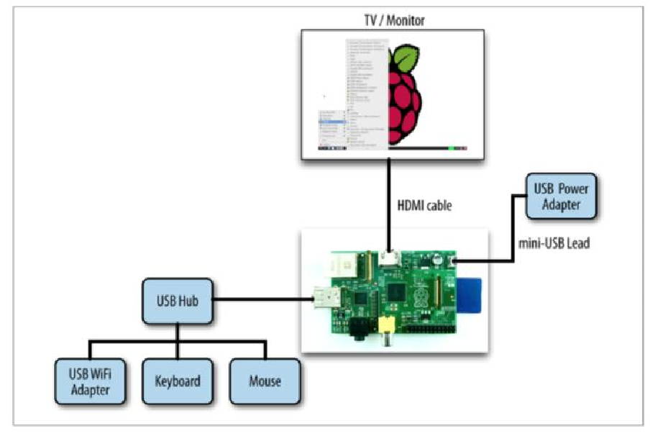

iii. WORKING

* You can consider the whole system to be composed of two parts:
  + Server.
  + Client.
* The server is the web interface consisting of buttons and UI (User Interface) that will allow you to turn ON/OFF a device.
* It consists of PHP files, Html files and a .txt file (to store data).
* The server usually stores

information regarding the button press on the page (ON/OFF) on a .txt file.

* This is a simple Html file called main.html , consisting of two buttons.
* The clicking of the buttons will trigger the execution of a PHP file called button.php.
* This program serves as an API to store data on to a text file called [buttonStatus.txt](https://diyhacking.com/projects/IOTautomation/buttonStatus.txt).
* The data is a string :
  + “ON”,
    - if ON button is clicked
  + “OFF”
    - if OFF button is clicked.

Raspberry Pi is an open source hardware technology combined with a programming language and an Integrated Development Environment (IDE).

The Raspberry Pi platform allows the user to create custom hardware and applications to control it via its namesake programming language.

Many software languages are available on the Raspberry Pi and I am interested in four. These are the C++, Python, SQL, and HTSQL. C++ uses for programming Arduino. HTSQL (Hyper Text Structured Query Language) to provide a web interface to database that is easy to query via the web browser. Operating systems that are available to install the Raspberry is Raspbian. Raspbian is based upon the Debian Wheezy Linux operating system and has been optimized for use with Raspberry Pi. The Raspberry Pi is connected to the Raspberry Pi's GPIO pins, and with the inclusion of the software, I will be able to communicate between our electronic devices, the Raspberry Pi's operating system, and web-based propose model.

* Thus the current button press state is recorded in the text file : buttonStatus.txt.
* The client side consists of a Raspberry Pi with a relay circuit connected to its GPIO pin.
* The pi runs a python program which is used to ‘Post’ a URL link using urllib2.
* That is, the pi constantly reads the contents of a URL link.
* Here, the URL link is another PHP file called buttonStatus.php.
* This PHP file serves as an API to read the contents of the text file buttonStatus.txt.
* After reading the data, the python program checks if the string obtained is “ON” / “OFF” based on which it switches ON/OFF the relay respectively via its GPIO pin.

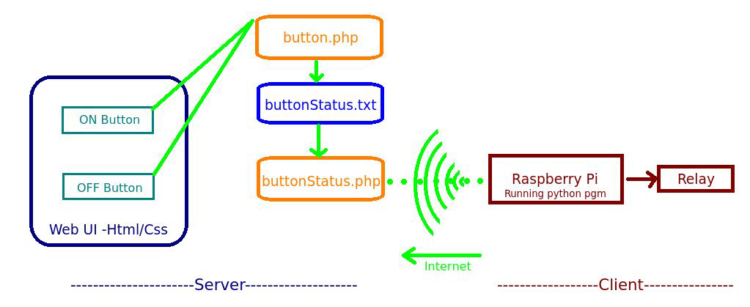

Fig.3 .Working

iv. ARCHITECTURE

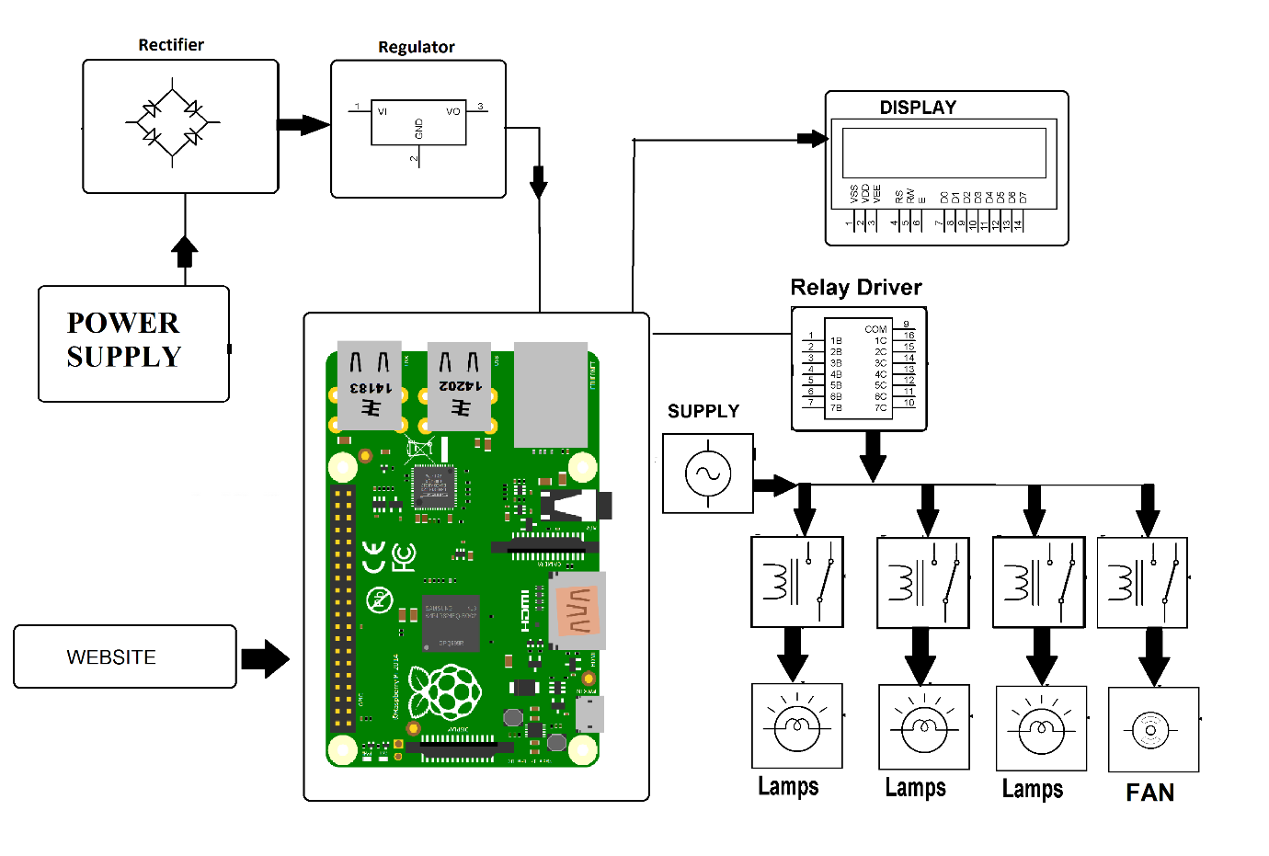

Fig. 4. Architecture of home automation using raspberry pi

Thus, the proposed system is better from the scalability, flexibility and security point of view than the commercially available home automation systems.

**vi. REFERENCES:**

1. <https://www.ijarcce.com/upload/2015/december-15/IJARCCE%2069.pdf>
2. <https://circuitdigest.com/microcontroller-projects/iot-raspberry-pi-home-automation>
3. <https://maker.pro/education/web-based-automation-for-your-home-with-raspberry-pi>
4. <https://www.raspberrypi.org/forums/viewtopic.php?t=191699>
5. <http://www.ijcsmc.com/docs/papers/May2015/V4I5201599a70.pdf>

# **v. CONCLUSION:**

The application of the IoT technology, in home automation means combination of all electrical devices like smart mobile phone, personal computer, tablet and their monitoring, controlling and alerting in ways not possible before. This proposed system provides many advantages including, safety, security, improved comfort, energy and cost savings. In order to address the issues of flexibility and functionality, a novel, standalone, flexible and low cost home controlling and monitoring system using Web services as an interoperable layer for communicating between the remotely present user and the home devices, have been designed. Performed research have shown that by using the Raspberry Pi and open source software it is possible to programmatically control many devices in a home in such a way that user can create his/her own solution customized to meet his/her individual needs.